

***Computer Programming 2 Project’s Report***

**Ain Shams University**

**Computer Engineering and Software Systems**

*Prepared by:*

Aly Mohammed Aly

Marina Gamal Ibrahim

Moussa Mohsen Moureed

Mohammed Said Mohamed Said

*Submitted to:*

Dr. Cherif Salama

**A brief description of the game:**

The game is composed of a paddle and a ball and some bricks, the player is supposed to clear all the bricks in order to proceed to the next level by bouncing the ball with the paddle, some power ups are used to help the player, the player starts the game with 3 lives, the player should avoid the ball from falling in order not to lose a life. Each level the ball speeds up and the paddle’s size is reduced and a new row of bricks is added to make it more difficult. It is composed of 10 levels.

Players gain score for breaking the bricks and they could save their high scores in the hall of fame.

**The implementation:**

We created an abstract class Shape which has initial x and y positions and an image as its members. Our implementation is based on the fact that the game components are all shapes with a drawn image. Classes Ball and Bar extend it. We also created a class for the Brick from which we construct the Bricks class, also we created a class for the PowerUp from which we construct the PowerUps class, we also initialized some constants in the Constants class to make changes in the code more efficient, we also created a HOF class (Hall of fame) to save the high scores, then there is the SaveScoreFrame class that asks the user to enter their name to save it in the Hall of Fame and outputs the name and score in a txt file, then there is our GameFrame class and StartFrame class which creates the start menu, there is also the GameOverFrame class that creates a frame to display a message when the player loses and then the CreditsFrame class containing our names. Finally there are the panels, StartPanel class and CreditsPanel class and the GamePanel class. The GamePanel class is supposed to hold the game contents(Ball , Bar ,Bricks) and is responsible for handling almost all events related to the gameplay and is part of the GameFrame class which is responsible for drawing the whole game.

**Bonus Features:**

* We added levels of various difficulties
* We added a hall of fame (best scores list)

**User guide:**

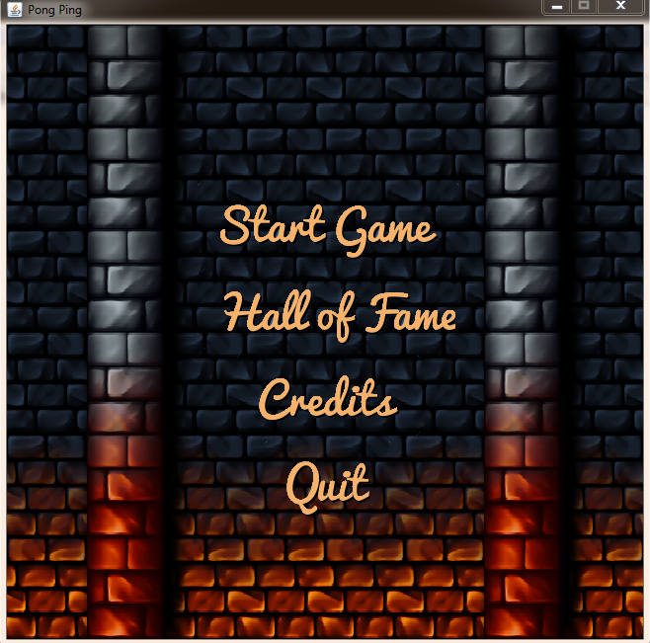First the player chooses one of the options from the start menu, he chooses whether he wants to start playing or to view the high scores or to quit the game.

**Credits:**

The player could go back to the start menu from the back button

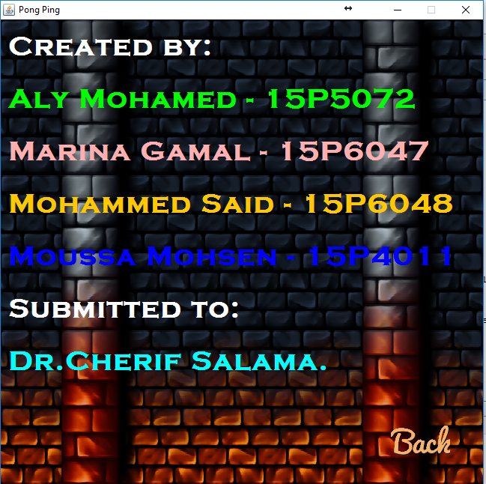

**Hall of Fame:**

After playing and winning the level a Frame opens which asks the player whether to continue playing or to save his score or to exit.

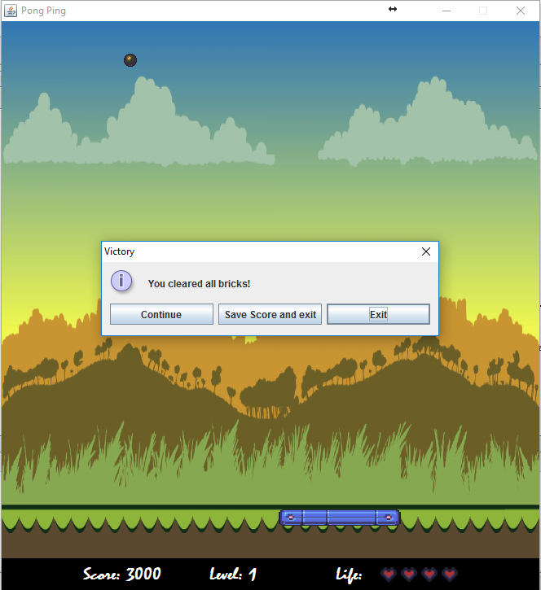

If the player lost a message is displayed that asks the user if he wants to exit or play again or save score.

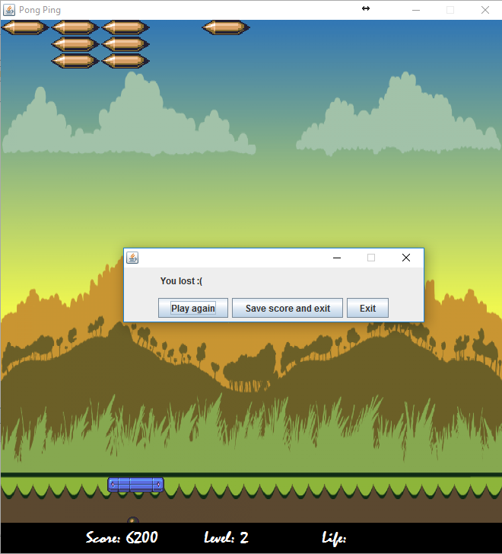

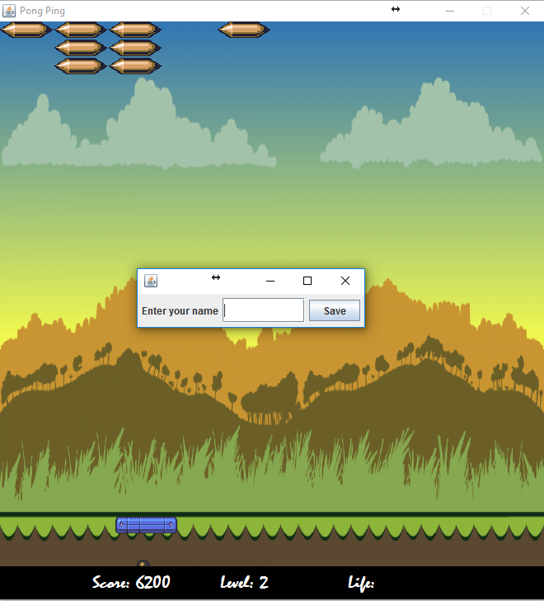

If the player chose the hall of fame from the main menu after saving his score he will see the high scores including his score. The scores are always sorted descendingly such that the highest score is always the first score.

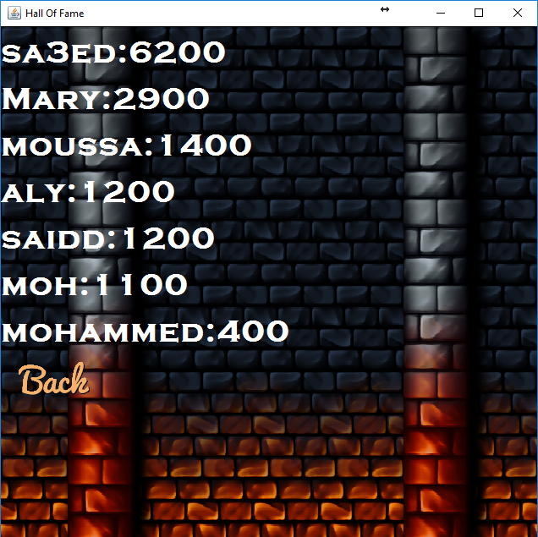

**Start Game:**

The game starts with the ball over the paddle and nothing will move until the player presses the left or right key. After a button is pressed, the ball starts moving and the player now has control over the paddle. The player can move the paddle either using the left and right keys or by using the mouse. Every 15 seconds, a random power up falls vertically downwards, if the player catches the power up through the paddle he gains an effect based on the power up.

C:\Users\user\Desktop\LifeIncrease.png

The give life power up grants an extra life.

C:\Users\user\Desktop\LifeDecrease.png

The remove life power up decreases the player’s lives by 1.

C:\Users\user\Desktop\GiveBall.png

The give ball power up increases number of bouncing balls by 1. This power up can increase as much balls as the player can handle. Losing an extra ball does not mean losing a life. Lives only decrease if the remaining 1 ball falls.

C:\Users\user\Desktop\BarIncrease.png

The increase bar length power up increases the length of the paddle by half its size. However, there is a maximum size for paddle so taking more of these will not infinitely increase the paddle size. If the player loses a life, the paddle size resets.

C:\Users\user\Desktop\BarDecrease.png

The decrease bar length power up has the same effect as the above power up but the opposite of it.

C:\Users\user\Desktop\BallSizeIncrease.png

The increase ball size power up increases the size of the ball by half its size. However, there is a maximum size for ball so taking more of these will not infinitely increase the ball size. If the player loses a life , the ball size resets.

C:\Users\user\Desktop\BallSizeDecrease.png

The decrease ball size power up has the same effect as the above power up but the opposite of it.

Pressing the space key pauses the game and displays a message indicating the game is paused. Pressing space again un-pauses the game and so on.

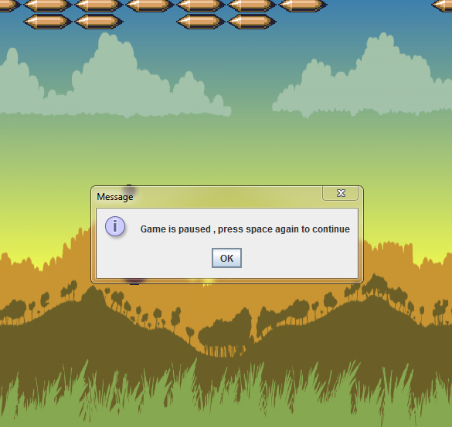

**Difficulties encountered and tricks used:**

In the beginning, we faced the problem of not knowing a lot of methods (only basic methods from the lecture) so we tried to implement the paddle just like the snake game example in the lecture. However, we later decided to use a whole rectangle and instead of using a grid, we used normal x and y coordinates. Another difficulty was to deal with images instead of standard shapes (a rectangle and a circle) for the paddles and ball. Making the whole game work together was also a difficulty since almost all game components interact together. Implementing the hall of fame was also a difficulty because we could not do it through a binary file so we decided to use a human readable file but its extension is .xml so the player can view the high scores file but he cannot change or edit it.

**How the work was split:**

Mohammed worked on the ball and paddle , especially ball motion.

Moussa worked on the paddle motion and collisions with the ball.

Aly worked on the bricks and their collision with the ball.

Marina and Moussa worked on the power ups.

Marina worked on the start frame and credits frame.

We worked together on the frames(GameFrame and GamePanel) to integrate our work as a whole.

In the end, Aly and Mohammed worked on the hall of fame.